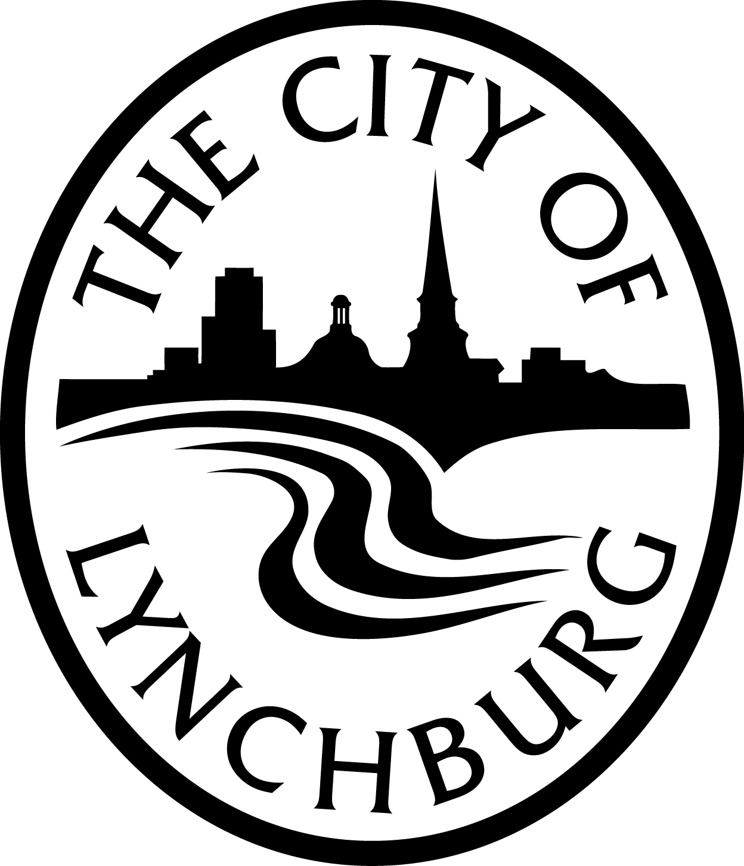

City of Lynchburg Arts & Cultural District Program
Advisory Panel Application
Arts & Cultural District Program Advisory Panel, under the direction of the Lynchburg Office of Economic Development (LOED), is created to make advisory recommendations on project funding requests. The five-member committee will review program applications three times per year, facilitated by LOED staff. Panelists will be selected on a rotating basis, appointed from a list of nominees compiled through solicitation of constituencies within the District.
Please complete this form and return to:
City of Lynchburg, Attn: Office of Economic Development
900 Church Street, Lynchburg, VA 24504
Email: Melissa.dismond@lynchburgva.gov
Fax: (434) 847-2067
Name:
Home Address:
Phone Number:
E-Mail Address:
Occupation: Employed by:
Do you live in the City of Lynchburg? Yes No
Are you currently a member of a City Board, Commission, Committee or Authority? Yes No
If yes, list the Board(s):

What talent(s) and/or experience can you bring to the Advisory Panel?

What do you feel you can contribute to the Panel and to the community that may not be evident from information already on this form?

A resume or separate sheet with additional information may be included.

Panelists will be appointed for their expertise in the arts, business, history, and any other criteria deemed necessary; their ability to work with others in a panel situation; and their willingness to devote the time required to review applications. Advisory Panel members will be obliged to recuse themselves from application review if they represent or are affiliated with an applicant.
The first class of panelists will be assigned a designated term ranging from one to three years. They may be appointed for up to three consecutive terms. All subsequent panelists will be chosen with current panel input via a public call for participation by LOED. All panelists must be able to attend review meetings three times per year. LOED retains the right to remove a panelist for any reason at any time.

